**Advance Excel Assignment 2**

1. What does the dollar ($) sign do?

An **absolute reference** in Excel is a cell address with the dollar sign ($) in the row or column coordinates, like $A$1.

The dollar sign fixes the reference to a given cell, so that it **remains unchanged** no matter where the formula moves. In other words, using $ in cell references allows you to copy the formula in Excel without changing references.

For example, if you have 10 in cell A1 and you use an **absolute cell reference** ($A$1), the formula **=$A$1+5** will always return 15, no matter what other cells that formula is copied to. On the other hand, if you write the same formula with a **relative cell reference** (A1), and then copy it down to other cells in the column, a different value will be calculated for each row. The following image demonstrates the difference:

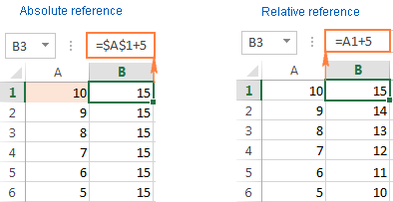

1. How to Change the Reference from Relative to Absolute (or Mixed)?

By default, a cell reference is a relative reference, which means that the reference is relative to the location of the cell. If, for example, you refer to cell A2 from cell C2, you are actually referring to a cell that is two columns to the left (C minus A)—in the same row (2). When you copy a formula that contains a relative cell reference, that reference in the formula will change.

As an example, if you copy the formula **=B4*C4** from cell D4 to D5, the formula in D5 adjusts to the right by one column and becomes **=B5*C5**. If you want to maintain the original cell reference in this example when you copy it, you make the cell reference absolute by preceding the columns (B and C) and row (2) with a dollar sign (**$**). Then, when you copy the formula **=$B$4*$C$4** from D4 to D5, the formula stays exactly the same.

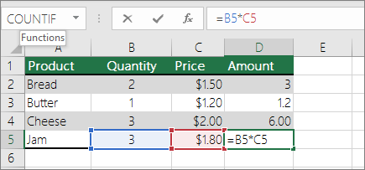

Less often, you may want to mixed absolute and relative cell references by preceding either the column or the row value with a dollar sign—which fixes either the column or the row (for example, $B4 or C$4).

To change the type of cell reference:

1. Select the cell that contains the formula.
2. In the formula bar Button image, select the reference that you want to change.
3. Press F4 to switch between the reference types.

The table below summarizes how a reference type updates if a formula containing the reference is copied two cells down and two cells to the right.

| **For a formula being copied:** | **If the reference is:** | **It changes to:** |
| --- | --- | --- |
| Formula being copied from A1, to two cells down and to the right | $A$1 (absolute column and absolute row) | $A$1 (the reference is absolute) |
|  | A$1 (relative column and absolute row) | C$1 (the reference is mixed) |
|  | $A1 (absolute column and relative row) | $A3 (the reference is mixed) |
|  | A1 (relative column and relative row) | C3 (the reference is relative) |

1. Explain the order of operations in excel?

**The order in which Excel performs operations in formulas**

In some cases, the order in which a calculation is performed can affect the return value of the formula, so it's important to understand how the order is determined and how we can change the order to obtain the results we want.

* **Calculation order**

Formulas calculate values in a specific order. A formula in Excel always begins with an equal sign (**=**). Excel interprets the characters that follow the equal sign as a formula. Following the equal sign are the elements to be calculated (the operands), such as constants or cell references. These are separated by calculation operators. Excel calculates the formula from left to right, according to a specific order for each operator in the formula.

* **Operator precedence in Excel formulas**

If you combine several operators in a single formula, Excel performs the operations in the order shown in the following table. If a formula contains operators with the same precedence—for example, if a formula contains both a multiplication and division operator—Excel evaluates the operators from left to right.

| **Operator** | **Description** |
| --- | --- |
| : (colon)  (single space)  , (comma) | Reference operators |
| – | Negation (as in –1) |
| % | Percent |
| ^ | Exponentiation |
| * and / | Multiplication and division |
| + and – | Addition and subtraction |
| & | Connects two strings of text (concatenation) |
| = < > <= >= <> | Comparison |

* **Using parentheses in Excel formulas**

To change the order of evaluation, enclose in parentheses the part of the formula to be calculated first. For example, the following formula produces 11 because Excel performs multiplication before addition. The formula multiplies 2 by 3 and then adds 5 to the result.

**=5+2*3**

In contrast, if you use parentheses to change the syntax, Excel adds 5 and 2 together and then multiplies the result by 3 to produce 21.

**= (5+2)*3**

In the following example, the parentheses that enclose the first part of the formula force Excel to calculate B4+25 first and then divide the result by the sum of the values in cells D5, E5, and F5.

**=(B4+25)/SUM (D5:F5)**

1. What, according to you, are the top 5 functions in excel and write a basic syntax for any of two?

**The top 5 functions in excel:**

* **The SUM Function**

The sum function is the most used function when it comes to computing data on Excel. This function works to sum a group of numbers in a specific set of cells. This means you don’t need to type a long cumbrous formula just to calculate the sum of all the data you need. Because of its popularity, newer versions of Microsoft Excel have a button specifically for this function.

This function is performed by typing the formula on the function bar and highlighting the cells we want summed before clicking “Enter”. We also need to be careful in highlighting cells, as Excel will sum everything we include. If this happens, we can easily click the “Undo” button to reset the values back to its original state.

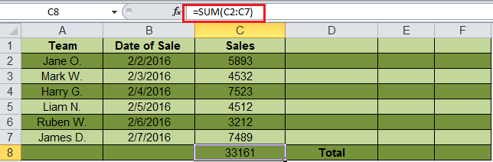**The syntax formula for sum function is** “=SUM” (number1, number2, etc.).

The sum function for the cells C2 through C7 is obtained through the formula “=SUM (C2:C7)”, giving you the result of 33161.

* **The TEXT Function**

Text function is a useful tool that helps convert a date (or number) into a text string in a particular format. It falls in the category of string formulas that converts numerical values to a string. It is handy when users need to view numeric data in a readable format. Take note that the “TEXT” formula only works to convert numeric values to text. Therefore, its results cannot be calculated.

**The syntax formula for textfunction is** “=TEXT” (value, format_text).

* “Value” refers to the number you wish to convert to text.
* “Format_text” defines the format of the conversion.

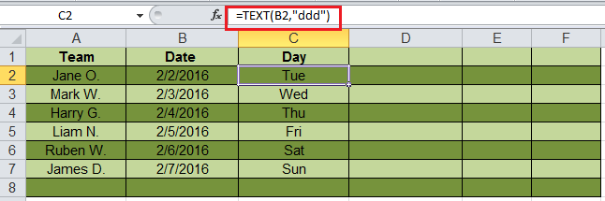

the user uses a text formula to find the abbreviated day for the date “=TEXT (B2, “ddd”)”.

* **The AVERAGE Function**

The average function is an extremely useful tool for getting the average value in a range of cells. Like the sum function, it is frequently used in computing and analysing data on spreadsheet. Basically, the average function works to find the “arithmetic mean” for a group of cells. Aside from the average function, Excel also has the median and mode function.

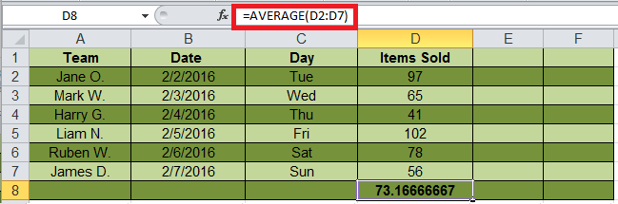

* **The CONCATENATE FUNCTION**

This function is a good time saver when you need to combine data from 2 or more cells. Unlike the merge tool which physically merges two or more cells into a single cell, the concatenate function only combines the contents of the combined cells. In the latest version of Excel (2016), the concatenate function has been replaced with concatfunction and will be incorporated in more future versions of Excel.

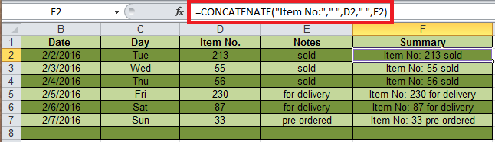

* **The COUNT Function**

The formula counts the number of cells in a range that contains number. So, if we want to count how many cells in a range contain number, we can use the formula =COUNT (A1:A10).

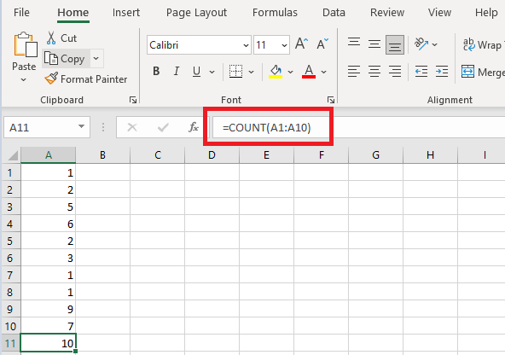

1. When would you use the subtotal function?

The SUBTOTAL Function in Excel allows users to create groups and then perform various other Excel functions such as SUM, COUNT, AVERAGE, PRODUCT, MAX, etc. Thus, the SUBTOTAL function in Excel helps in analysing the data provided.

**Formula**

**SUBTOTAL = (method, range1, [range2 …range_n])**

Where method is the type of subtotal you wish to obtain

Range1, range2…range_n is the range of cells you wish to subtotal

**Why do we use subtotal?**

Sometimes, we need data based on different categories. SUBTOTALS help us to get the totals of several columns of data broken down into various categories.

For example, let us consider garment products of different sizes manufactured. The SUBTOTAL function will help you to get a count of different sizes in your warehouse.

1. What is the syntax of the VLOOKUP function? Explain the terms in it?

VLOOKUP is powerful Excel function that is often overlooked. Users will find it useful when they need to find specific data on a large table. You can also use VLOOKUPto search for names, phone number, or specific data on your sheet. Instead of manually looking for the names and wasting time scrolling through hundreds of data, the VLOOKUP function makes this process faster and more efficient.

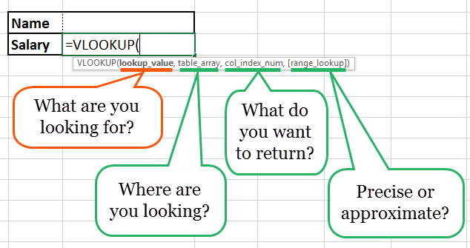

The VLOOKUPformula is “=VLOOKUP” (lookup_value, table_array, col_index_num, *range_lookup*).

* “lookup_value” is the data you want to find.
* “table_array” is the data column where you want to limit your search.
* “col_index_num” is the column number within the table that you want to return a value from.
* “range_lookup” is an optional argument that allows you to search for the exact match of your lookup value without sorting the table.